AM000-Asia-China-Yuan-Two Phoenix-One Pagoda-Four Running Animals-Eight Birds-Eight Arc

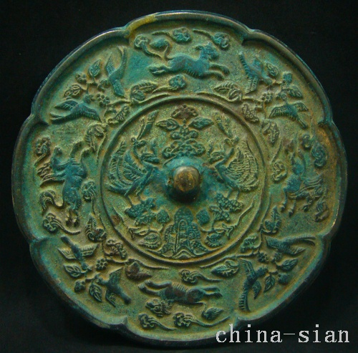

Diameter 141  mm     Deep  4.5  mm